**Task 3: Google Knowledge Graph Search API**

**1)Introduction:**

To develop a web app using Google graph search API.

**2)Objectives:**

The main objective of this angular based app is user searches a notable entities like places, persons, things etc. It should show the details of the search entity.

**3) Approaches:**

i.We must create name of the task.

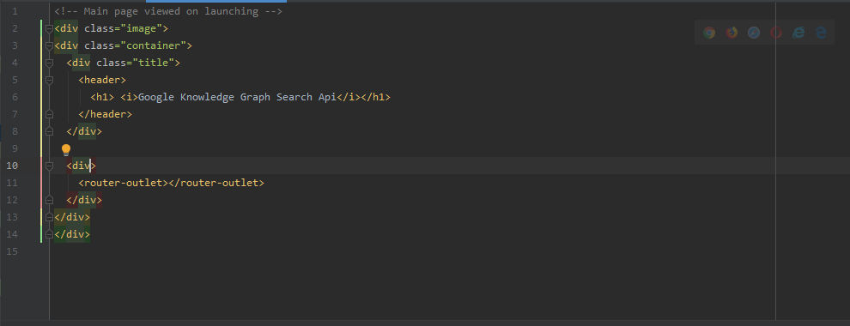

ii.We have to create the search bar.

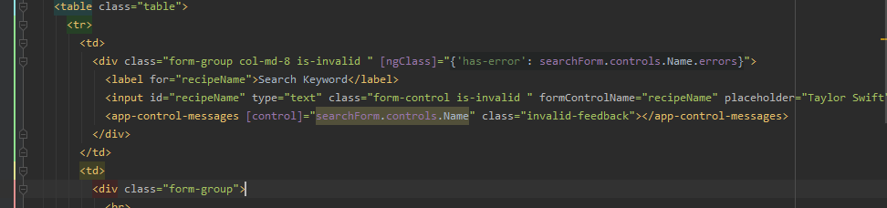



iii.We have to develop code for the results in which the search term related information should be displayed.

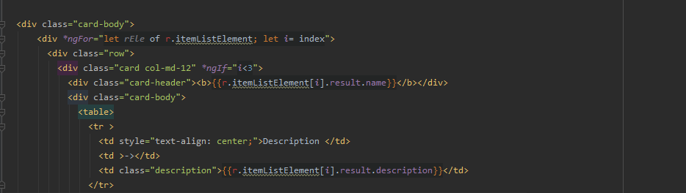

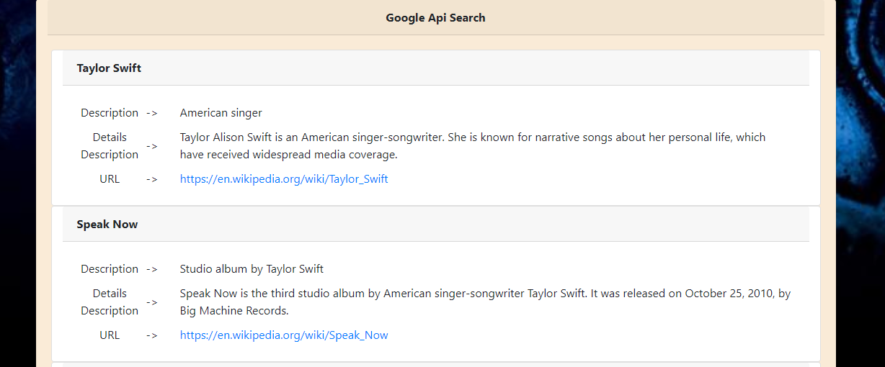

**4.WorkFlow:**

i.The customer types the notable entity in the search bar and clicks the button.

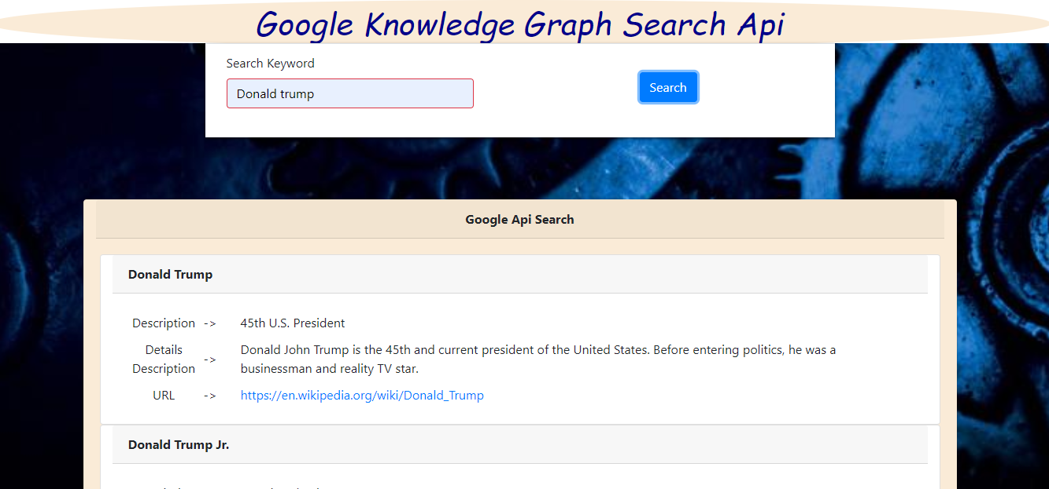

**5.Conclusion:**

We got know about how to use APi’s in Angular and generating the output response.